# Download and setup Docker

<https://docs.docker.com/install/#supported-platforms>

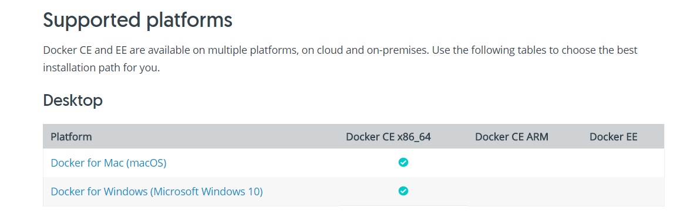

# Pull image from docker hub

Open Windows PowerShell and type in your command

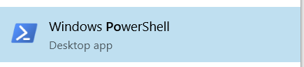

docker pull andypetrella/spark-notebook:0.9.0-SNAPSHOT-scala-2.11.8-spark-2.2.1-hadoop-2.7.2-with-hive

Check your image list

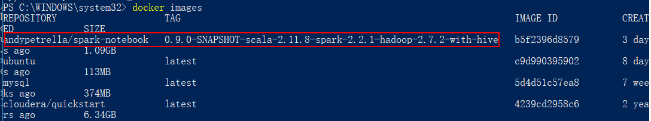

Run

docker run -p 9000:9000 -p 4040-4045:4040-4045 andypetrella/spark-notebook:0.9.0-SNAPSHOT-scala-2.11.8-spark-2.2.1-hadoop-2.7.2-with-hive

Then do not do anything within this window

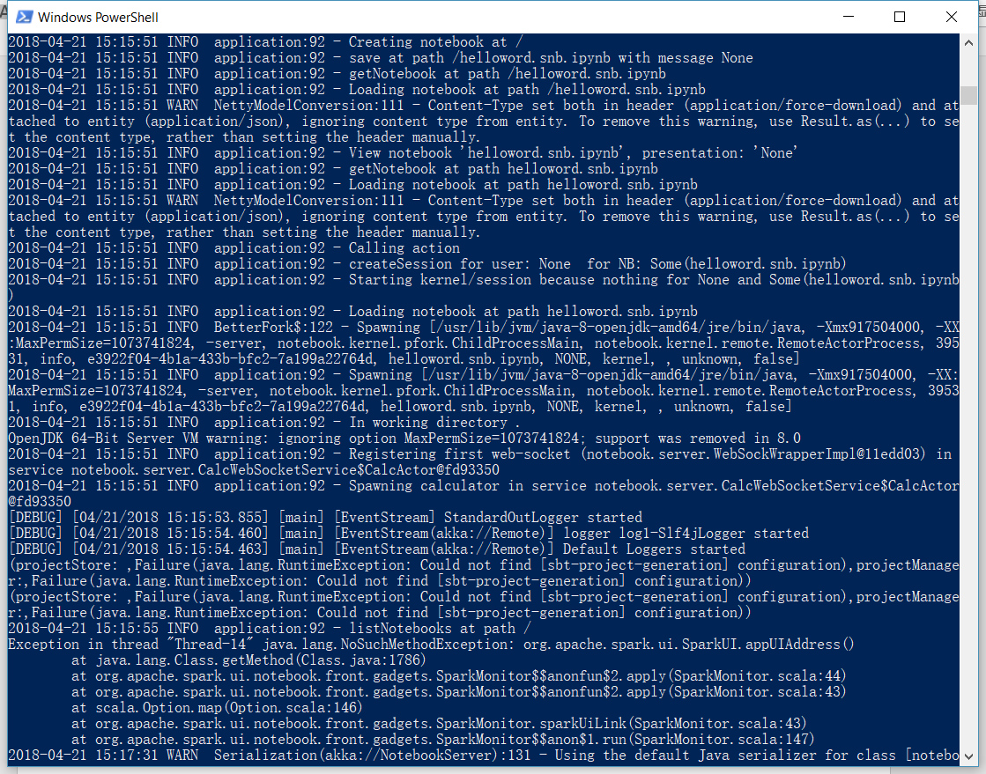

# Start you code on Spark Notebook

Open browser and type the address

localhost:9000

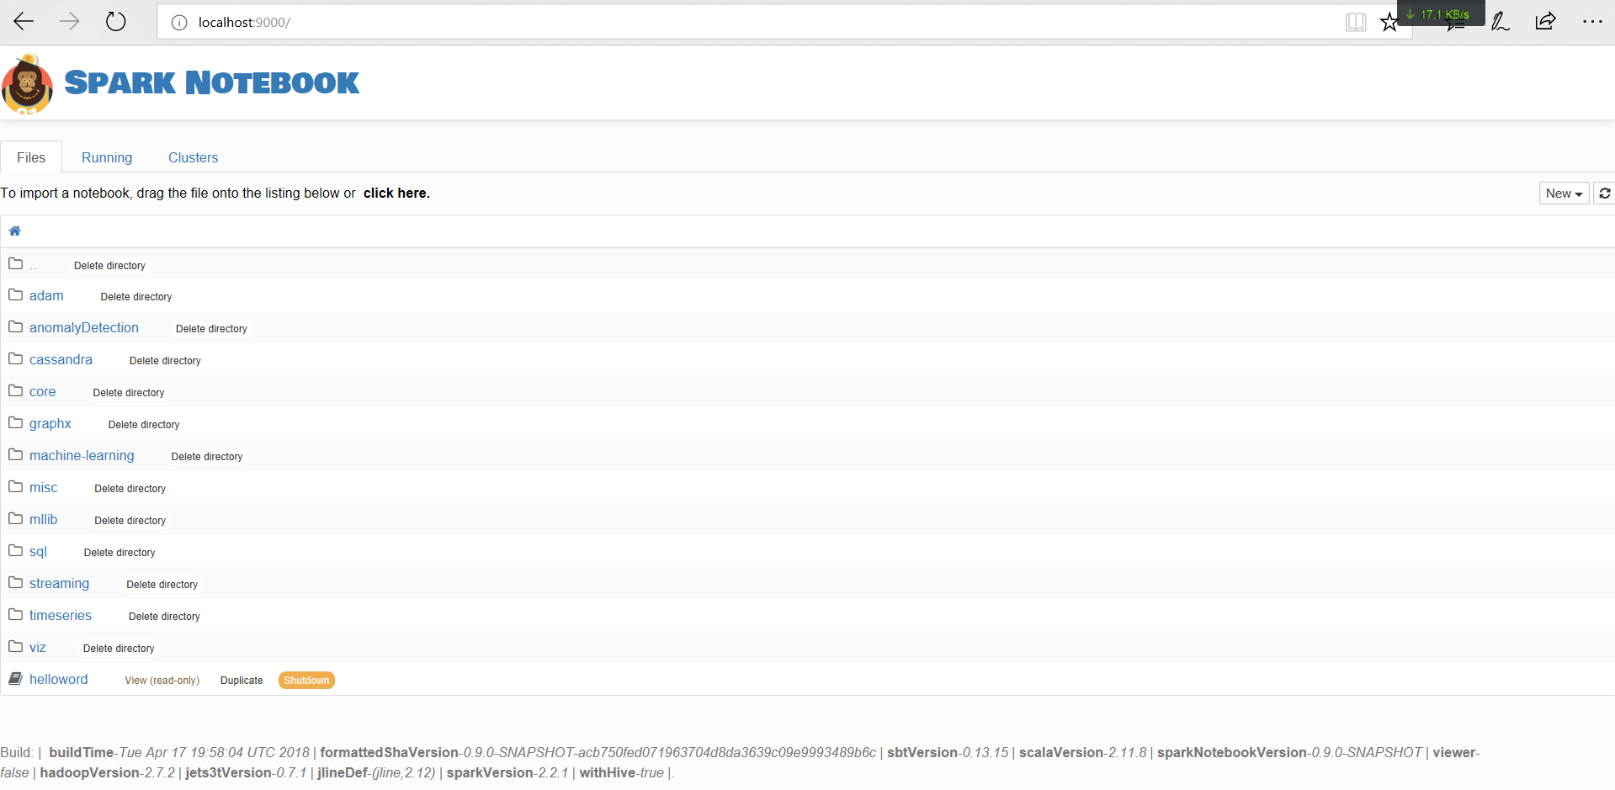

Create your own notebook

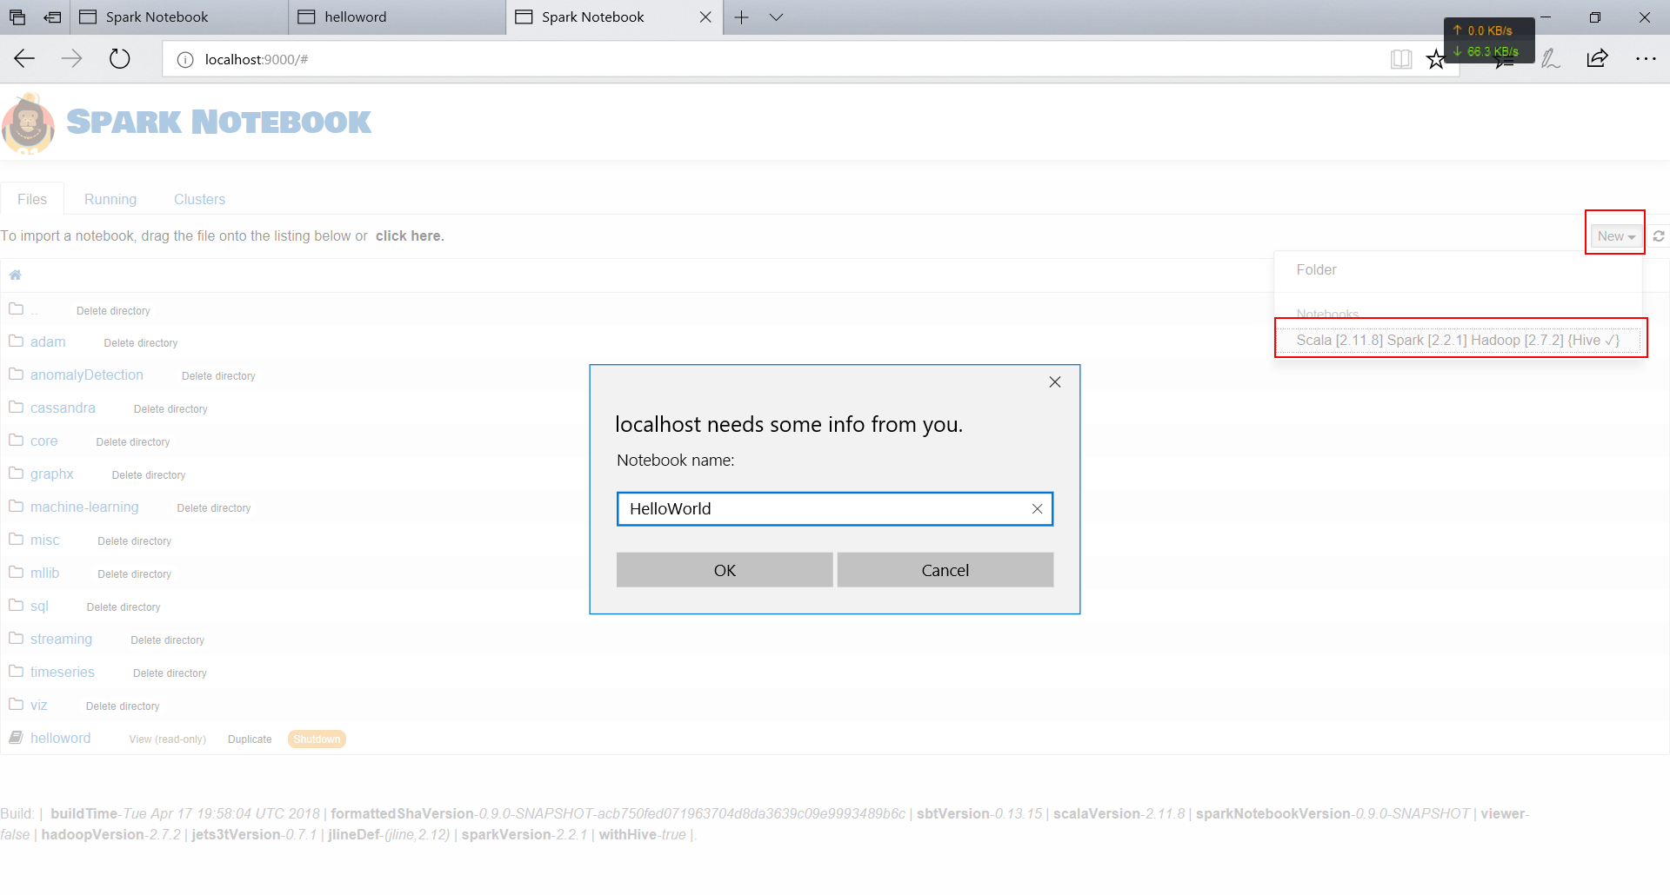

Start coding(example: print “hello world”)

